MAKING B-LOGO ON CANVA

INTRODUCTION

My Team I’D- NM2023TMID41279

My Team Leader:

C. SARANYA-1D3F31AFF9CA21D8DFC414883BE4389A

My Team Members:

S. POORNIMA-EEE133458BB7369AEB64243A9CA5FAB0

M.SEETHADEVI-F8FCE31D626ECD8AC314C7E873338456

N. SRINITHI-F98FCDDAAFB45ED9A534CAF8CA1B2593

My Team Project :

Project Name B-LOGO

Me and my team members achieved in a B-LOGO design

DEFINITION &DESIGN THINKING PROBLEM

Empathy Map

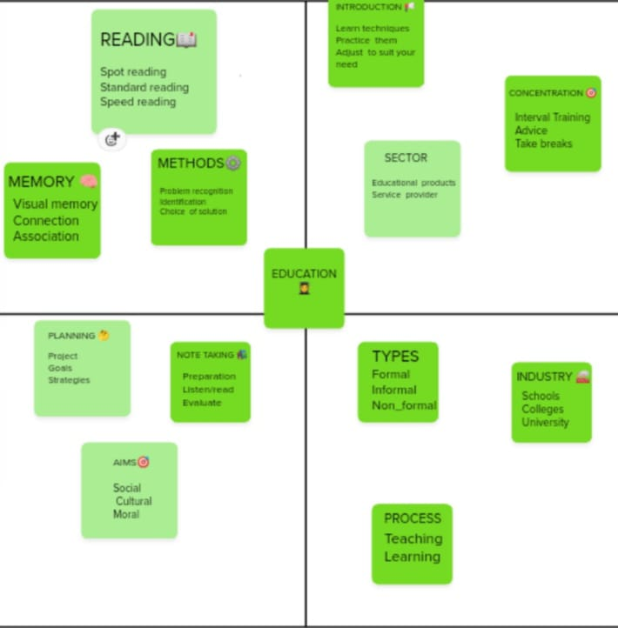

Brainstorming Map

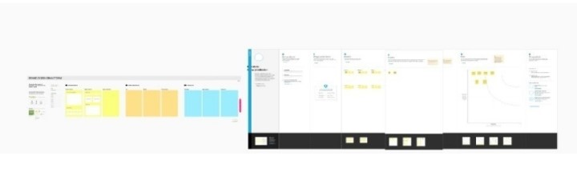

RESULT



ADVANTAGES

I will prepare many B-LOGO from this opportunity. It is very easy to customize designs and colours and fonts.

So, why is a logo important? Because it grabs attention, makes a strong first impression, is the foundation of your brand identity, is memorable,

APPLICATIONS

Search design on canva

Then select Education design and change that colours and fonts.

CONCLUSION

These are the things we have done this project.